**公司简介**

**甘肃普华甜菊糖开发有限公司**

我们是专业的甜菊糖生产商，始终坚持以市场需求为导向，努力优化产品结构和拓展客户渠道，目前拥有甜菊糖苷TSG系列、高RA系列、高STV系列、酶改质系列以及餐桌糖等系列产品。我们将以丰富的经验和先进的生产技术为您提供高质量的甜菊糖苷系列产品和全过程服务，相信通过我们的优质服务，确保原料＋产品＋技术支持的整个供应链。

我们期待与您共赢发展**。**

**Company Profile**

**Gansu Puhua Stevia Development Co., Ltd.**

We are a professional stevia manufacturer, always adhere to the market demand-oriented, and strive to optimize product structure and expand customer channels. Currently, we have steviol glycoside TSG series, high RA series, high STV series, enzyme modified series and table sugar series. product. We will provide you with high-quality steviol glycoside products and full-process services with rich experience and advanced production technology. We believe that through our high-quality services, we will ensure the entire supply chain of raw materials + products + technical support.

We look forward to a win-win development with you.

**企业发展理念**

**原料基地+自主研发+生产销售**

**公司产品**

RA99

RA98

RA97

RA95

RA90

SG95RA80

SG95RA60

SG90RA50

RD(Rebaudioside-D)

STV(Stevioside)

STV60

Glucosyl steviol glycoside series

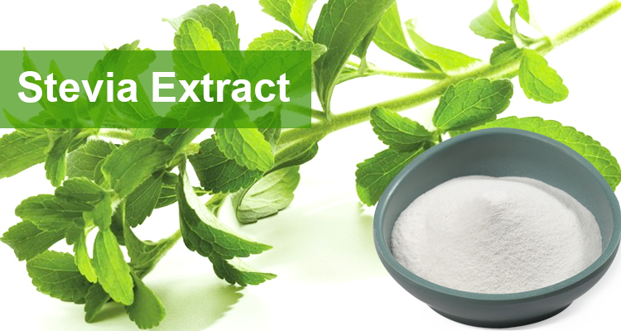

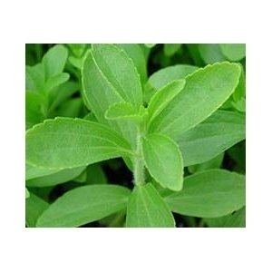

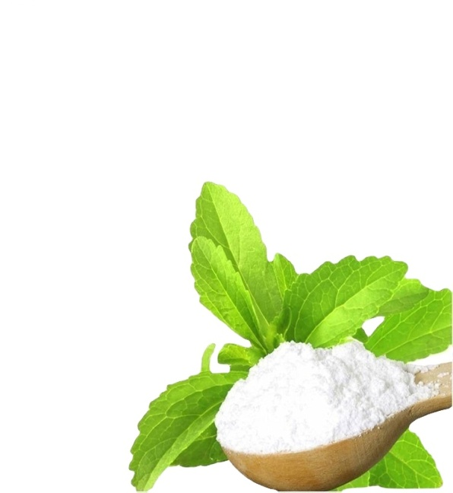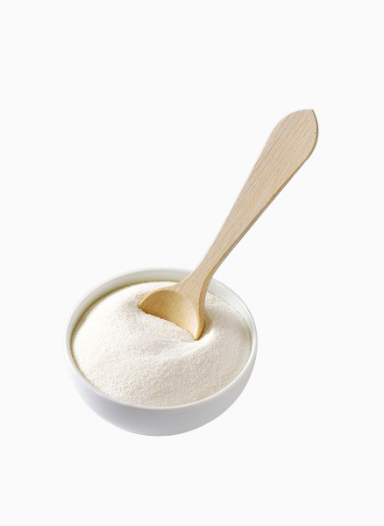

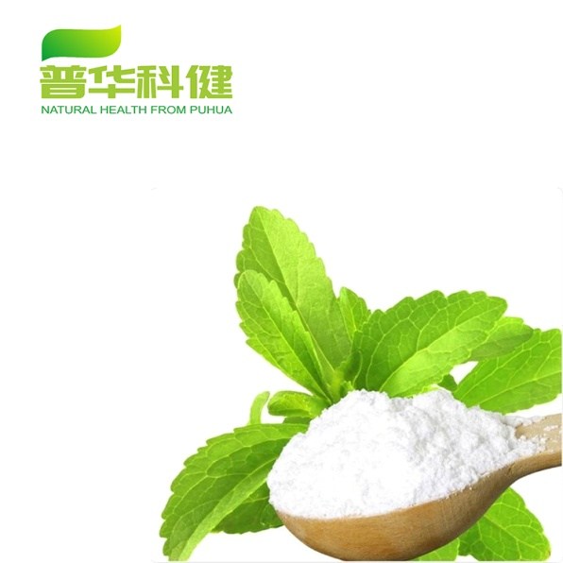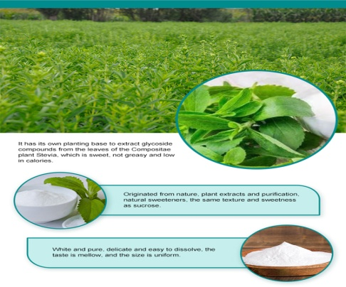

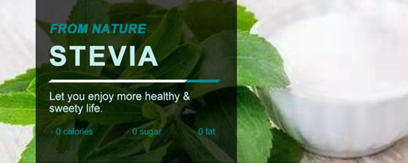

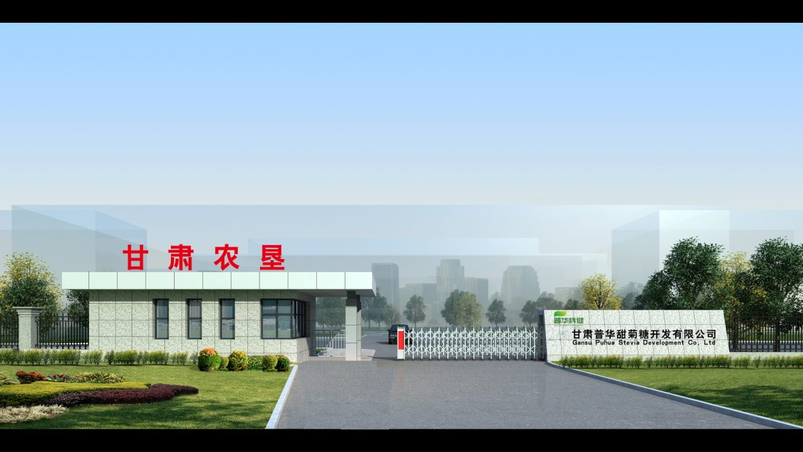

LOGO 公司官网：http://www.gspuhua.com/

（公司简介不体现也可，产品需体现，设计以绿色为主）

绿色天然提取 创造健康生活

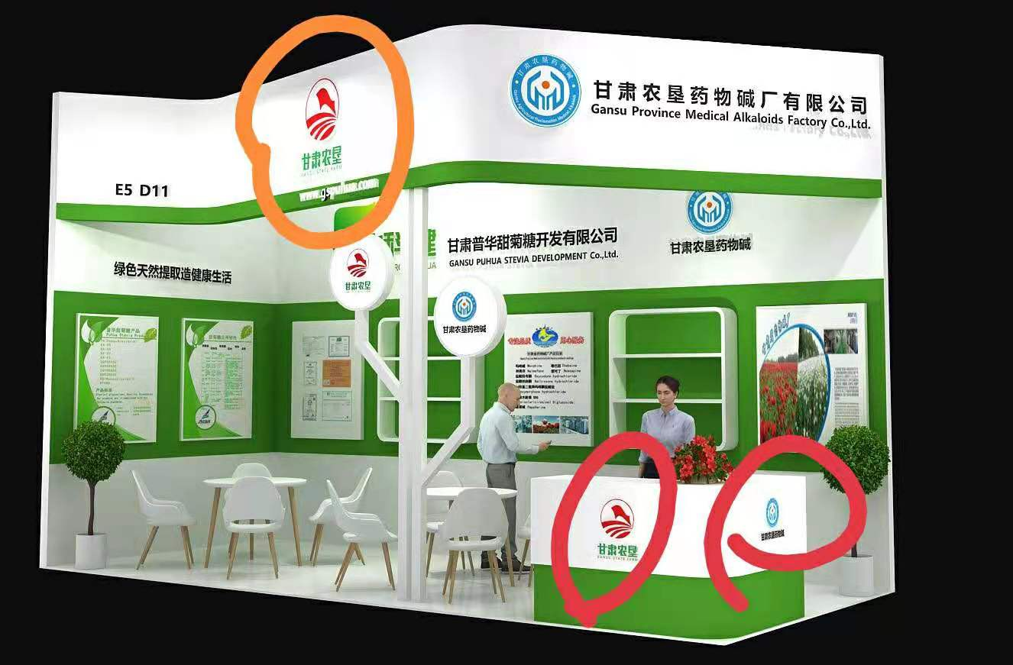以往设计图请参照